**‘AccessBank DBA Internship Program’**

**Project 22: import and export via BCP utility**

**Theory**

If you open CSV (**C**omma **S**eparated **V**alue) file with a text editor, you can see the actual **commas** which are also called as **separators or delimiters**. These commas are important, because while bcp utility is inserting values from CSV file into SQL table, it coordinates values for each column in the table and inserts values correctly by the help of those commas. You can’t see those commas with Excel software. Excel will show you CSV file in a user-friendly format.

You can find more info and examples about bcp from official Microsoft documentation: <https://docs.microsoft.com/en-us/sql/tools/bcp-utility?view=sql-server-ver15>

**Please accomplish the following tasks using BCP utility:**

1. Export data from Person.Person table into txt file

**I used bcp databasename.schemaname.tablename {in/out/queryout} filepath -T(for trusted(Windows) credentials) -c(to tell cmd that is character data) structure to export table into file:**

**bcp AdventureWorks2014.Person.Person out “c:\users\new folder\person.txt” -T -c**

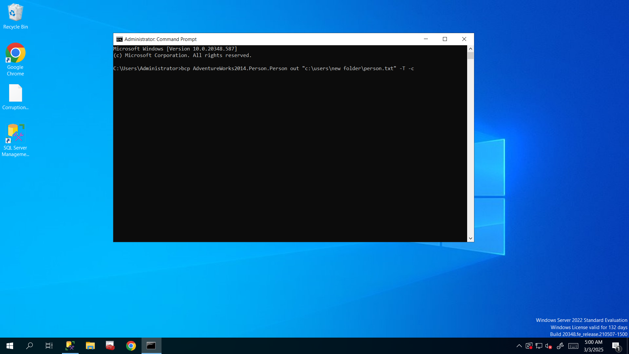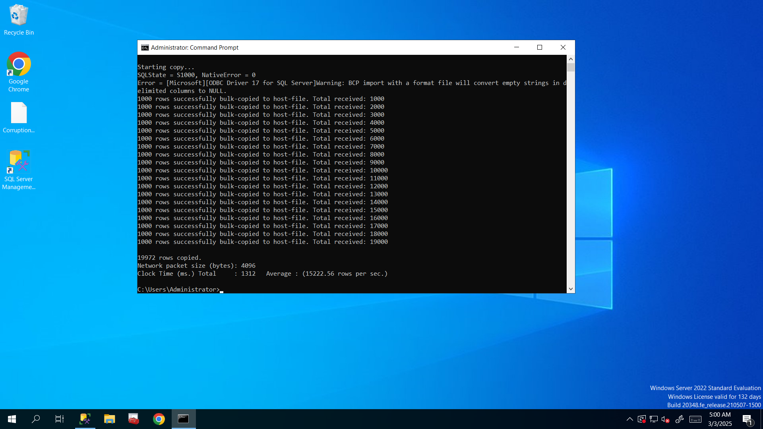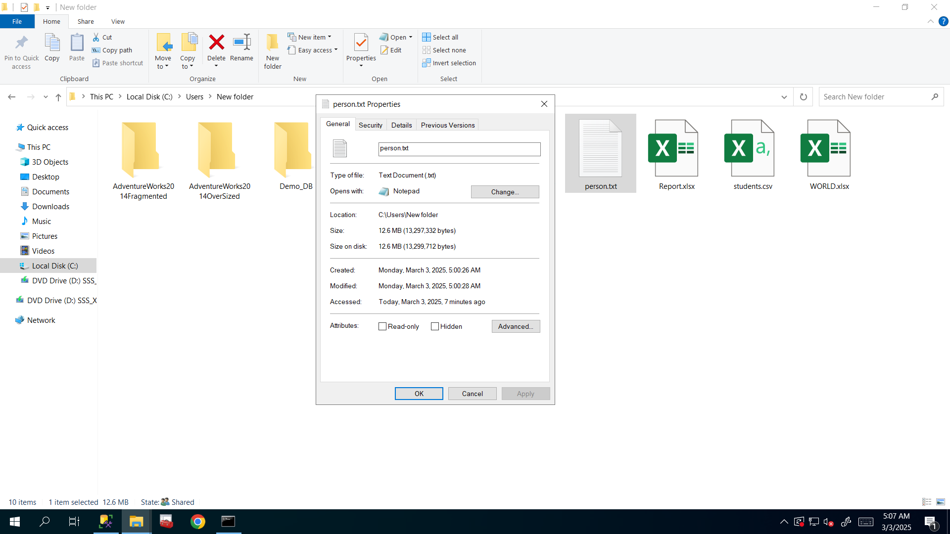

1. Import data from given CSV file into table

**For importing I will change ‘out’ word to ‘in’ and for .csv(comma is delimiter) I will use ‘-t,’ to determine ‘,’ as delimiter instead of tabs.**

**bcp AdventureWorks2014.dbo.students in "c:\users\new folder\students.csv" -T -c -t,**

Hint 1: Create a table called students.

Hint 2: By looking into given CSV file, you can determine the column names and their data types.

**Here I created students table after looking at what’s in that csv file**: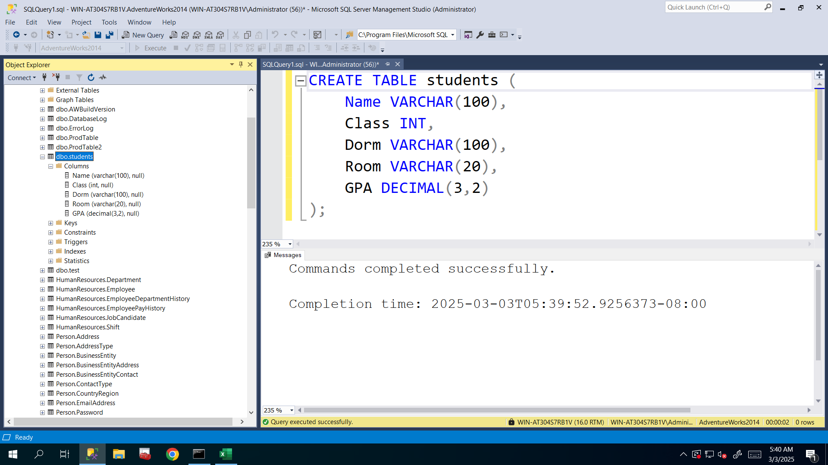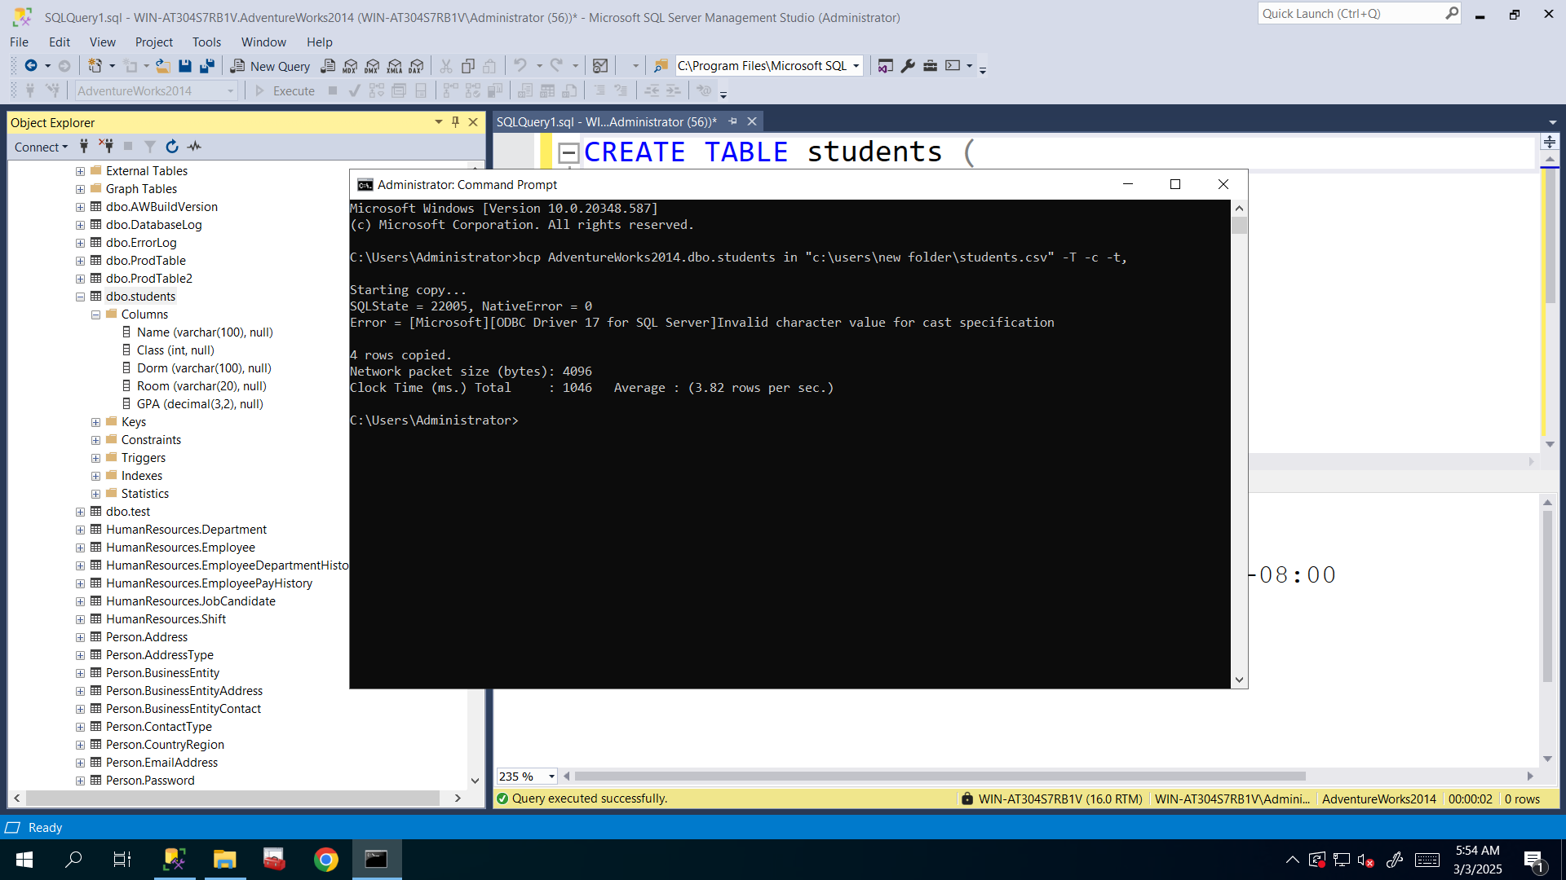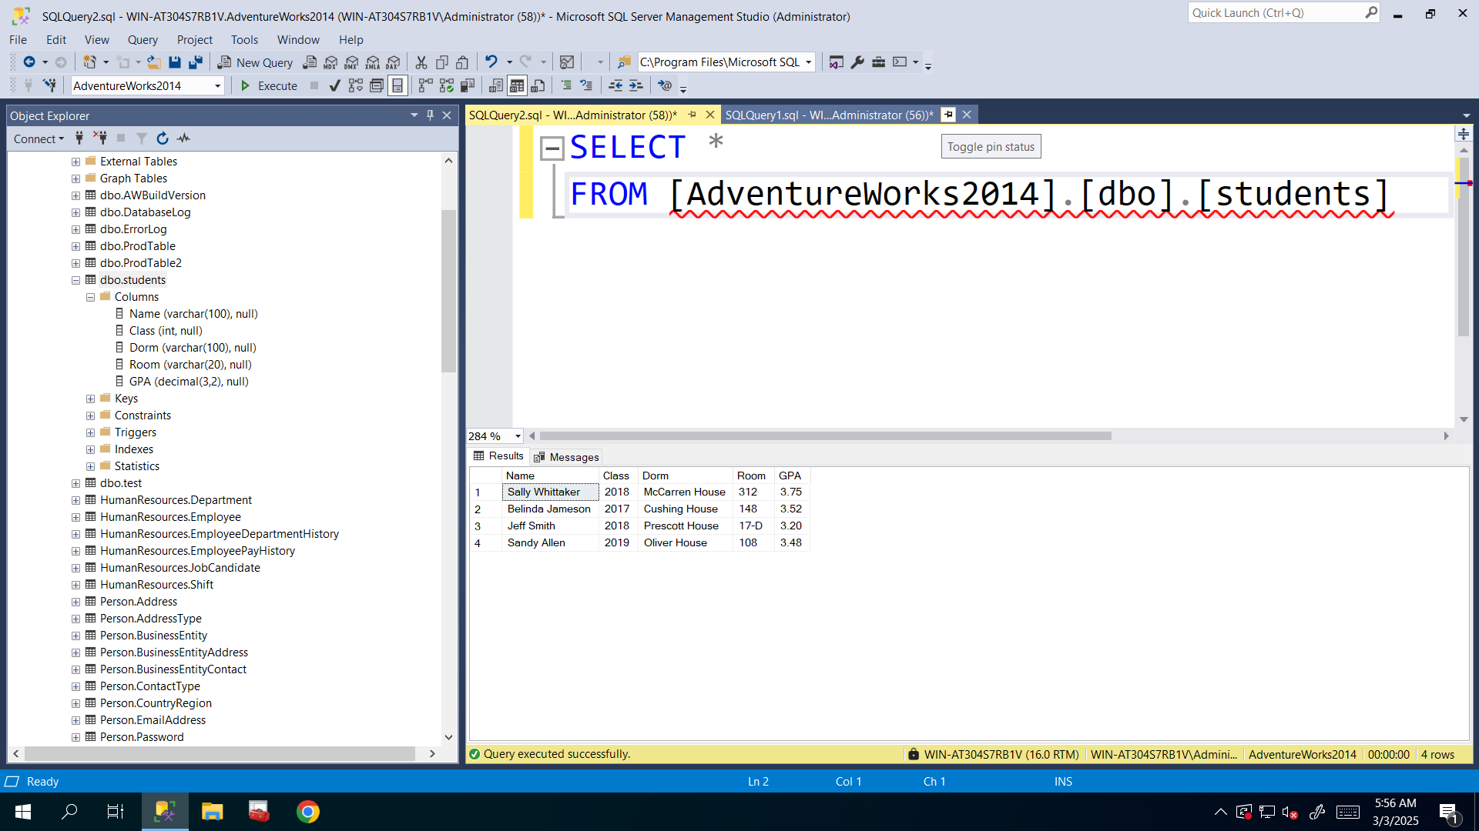

1. Export the output of the given query into CSV file

SELECT [Name], [ProductNumber] FROM [AdventureWorks2014].[Production].[Product] WHERE [SafetyStockLevel]>500

**Here I used query to export data into file so I changed ‘in’ word to ‘queryout’**

**bcp "SELECT [Name], [ProductNumber] FROM [AdventureWorks2014].[Production].[Product] WHERE [SafetyStockLevel]>500" queryout "c:\users\new folder\products.csv" -T -c -t,**

